# User Stories

Below are the user stories for this website. Understanding of the user stories can be assisted by reference to the UI/UX prototype.

## List of User Stories

**User Story 1:**

|  |  |  |  |
| --- | --- | --- | --- |
| **Statement** | **Acceptance Criteria** | **Estimation\*** | **Priority** |
| As a learner, I want to view information of the country of each of the Flag Image-Country Name pairs I click on in the Repository (homepage), so that I could learn more about the selected country. | 1. User should be able to select any of the Flag Image-Country Name pairs in the Repository (home page). 2. A new page should open up with information of the country of the selected Flag Image-Country Name pair. 3. Information should be accurate and up to date. | Story Points: 8 | **Priority: 1**  High Priority |

**User Story 2:**

|  |  |  |  |
| --- | --- | --- | --- |
| **Statement** | **Acceptance Criteria** | **Estimation\*** | **Priority** |
| As a learner/quiz taker, I want to be able to view all the Possible Answers of the Flags or Countries Challenges without having to scroll down the page, so that no countdown time is wasted. | 1. All of the 4 Possible Answers per question in the Flags and Countries Challenges should be visible on the screen at the same time, in both desktop and mobile view. 2. All the Possible Answers should be the same size on the screen. 3. All possible answers should be selectable. 4. This should work the same in all the platforms (e.g., desktop and mobile). | Story Points: 5 | **Priority: 1**  High Priority |

**User Story 3:**

|  |  |  |  |
| --- | --- | --- | --- |
| **Statement** | **Acceptance Criteria** | **Estimation\*** | **Priority** |
| As a learner/quiz taker, I want to see my result immediately after the attempt of each question, so that I could learn from my correct and incorrect answers. | 1. A sound effect should be played upon the selection of each possible answer to indicate whether the answer is correct or not. 2. An icon (tick or cross) should appear, superimposed on the selected Possible Answer, to indicate whether the answer is correct or incorrect. 3. All incorrect Possible Answers should fade to place emphasis on the correct Possible Answer. 4. A button pops up, allowing the user to move on to the next question. | Story Points: 5 | **Priority: 1**  High Priority |

**User Story 4:**

|  |  |  |  |
| --- | --- | --- | --- |
| **Statement** | **Acceptance Criteria** | **Estimation\*** | **Priority** |
| As a learner/quiz taker, I want to see my score at the end of each Flags or Countries Challenge, so that I could understand the level of my knowledge. | 1. A dedicated page open at the end of each Challenge, displaying the numbered score out of a total of 20 that were achieved for that Challenge, and how many ‘lives’ out of a total of 3 that were remaining at the end of that Challenge. (A ‘life’ is represented as a ‘heart’ icon. A life is lost when an answer is incorrect, or the countdown timer reaches zero). 2. A button allows the user to end the Challenge, which effectively returns to the home page. 3. A button allows the user to replay the Challenge. | Story Points: 8 | **Priority: 1**  High Priority |

**User Story 5:**

|  |  |  |  |
| --- | --- | --- | --- |
| **Statement** | **Acceptance Criteria** | **Estimation\*** | **Priority** |
| As a learner/quiz taker, I want to be able to access the app on my mobile device, so that I could learn or test my geography knowledge anywhere with a phone but no access to a computer. | 1. The page contents should be responsive in smaller screen sizes. 2. All the key contents throughout the website should be maintained even if the website is adjusted to smaller screen sizes. 3. All the pages should be quick to load, to account for possible lower internet bandwidth on mobile devices. | Story Points: 8 | **Priority: 1**  High Priority |

**User Story 6:**

|  |  |  |  |
| --- | --- | --- | --- |
| **Statement** | **Acceptance Criteria** | **Estimation\*** | **Priority** |
| As a learner/quiz taker, I want each question to feel unique, so that there is variety between all the questions. | 1. For each question, the Prompt, along with 3 incorrect Possible Answers, should be randomly presented to the user. 2. For each question, there is no duplicate Possible Answer, i.e., each Possible Answer only appears once per question. 3. For each Challenge, the same Prompt is not presented more than once throughout the 20 questions. | Story Points: 5 | **Priority: 2**  Medium Priority |

**User Story 7:**

|  |  |  |  |
| --- | --- | --- | --- |
| **Statement** | **Acceptance Criteria** | **Estimation\*** | **Priority** |
| As a quiz taker, I want to receive visual feedback on each of the possible answers that my mouse hovers over on desktop, or long press on touch screen, so that I would have verification of my prospective selection before confirming it. | 1. The opacity of each of the Possible Answers should decrease when it is hovered over by the mouse on desktop device, or is long pressed on mobile device. 2. The opacity should return to normal if the mouse hovers out of the Possible Answer on desktop device, or long press is released from the Possible Answer on mobile device. | Story Points: 3 | **Priority: 2**  Medium Priority |

**User Story 8:**

|  |  |  |  |
| --- | --- | --- | --- |
| **Statement** | **Acceptance Criteria** | **Estimation\*** | **Priority** |
| As a learner/quiz taker, I want to be able to navigate to any page on the website regardless of which point on the website I am on, so that I could access different parts of it quickly. | 1. The navigation bar should be accessible and fixed on the page at any point on the website. 2. The navigation bar should contain hyperlinks to any part of the website. 3. This should work the same in all the platforms (e.g., desktop and mobile). | Story Points: 8 | **Priority: 3**  Low Priority |

**User Story 9:**

|  |  |  |  |
| --- | --- | --- | --- |
| **Statement** | **Acceptance Criteria** | **Estimation\*** | **Priority** |
| As a learner/quiz taker, I want to be able to choose the difficulty level of each challenge before taking it, so that I could customise my learning or quiz taking based on my abilities. | 1. When the Flags or Countries Challenge is opened from the navigation bar, a dedicated screen should display the different difficulty levels for the user to select. 2. The difficulty levels should be in ascending order (least difficulty at the top, greatest difficulty at the bottom) 3. Each Flag or Country Prompt should not appear in more than one difficulty level. | Story Points: 8 | **Priority: 3**  Low Priority |

# UX/UI Design

### Desktop UX/UI - Key Features

#### Navigation

The navigation bar is fixed in position and spans across the entire width of the website (Figure 7). It serves as both the banner of the website and the portal to which the user could navigate to any other pages from anywhere on the website.

One of its features is a search box, allowing the user to search the name of any country to view its information, which is a quicker alternative than locating and selecting it in the Repository in the home page.

#### Content

The content is presented in two layout types throughout the website:

* + - * + One-Column Layout

Used for:

Repository (home page) (Figure 1) - houses all Flag Images and Country Names. The Flag Image-Country Name pairs are presented in alphabetical order, with respect to Country Names. Each row contains 4 Flag Image-Country Name pairs. This page is scrollable.

Contact page - contains the contact form and information of the business contact details and address.

* + - * + Two-Column Layout:

Flags Challenge (Figure 3) and Countries Challenge (Figure 5) pages - The primary content is on the right column, where the questions are presented. The secondary content is on side panel on the left column, providing metric information of the challenge.

### Mobile UX/UI - Key Features

#### navigation

The navigation bar is accessed via three-line menu icon that is fixed in position in the banner of all pages (Figures 9 to 16). Tapping into this icon expands the navigation bar, showing the links to all the pages, presented in a vertical stack manner (Figure 10). Tapping into any area outside of the navigation bar closes it.

It features the search box, allowing the user to search the name of any country to view its information, which is a quicker alternative than locating and selecting it in the Repository in the home page.

#### Content

The content is presented in a one-column layout throughout the website (Figures 9 to 16). All major page elements behave as block elements, stacking on top of each other.

## Sample Screenshots

### Desktop UX/UI

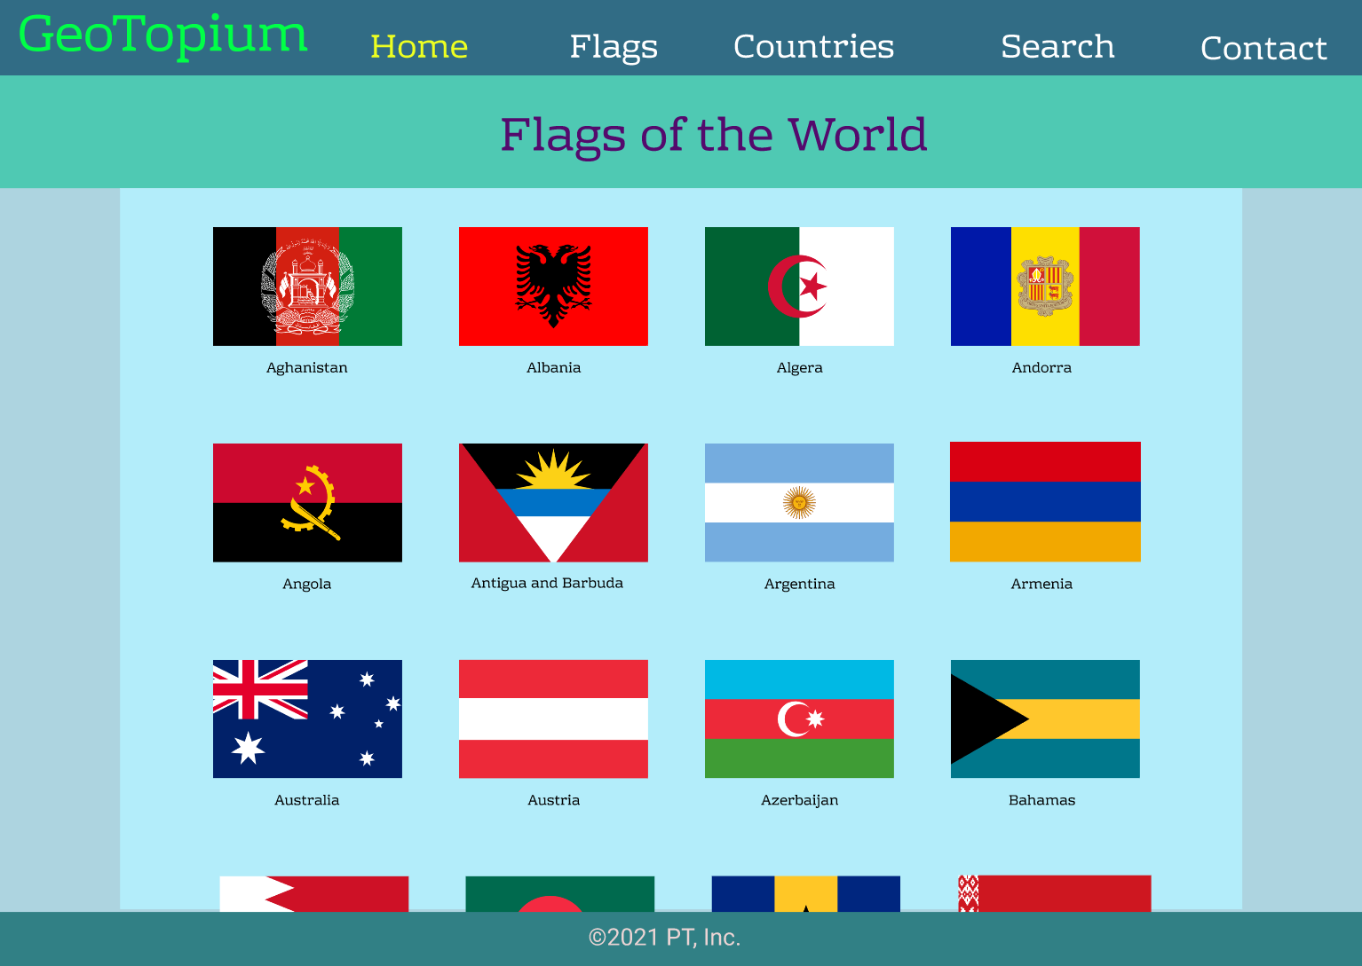

Figure 1: Home Page (Repository) [Desktop View]

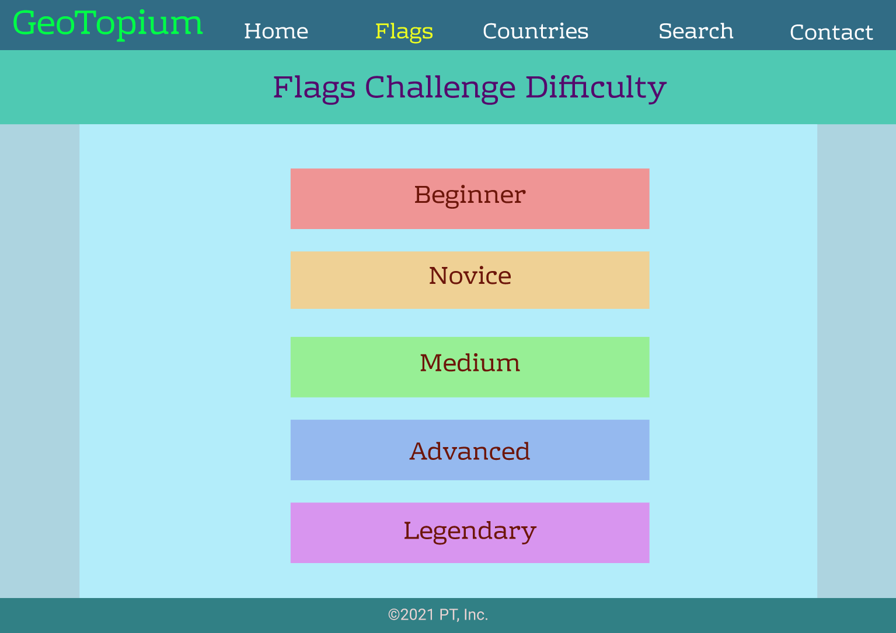

Figure 2: Flags Challenge - Difficulty Selection Page [Desktop View]

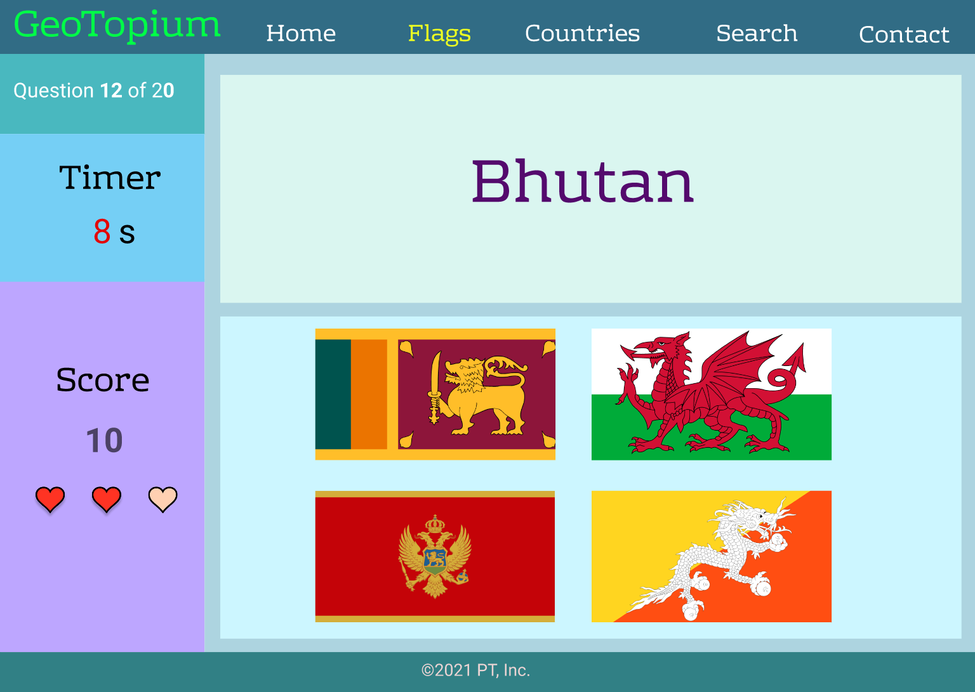

Figure 3: Flags Challenge - Question Page [Desktop View]

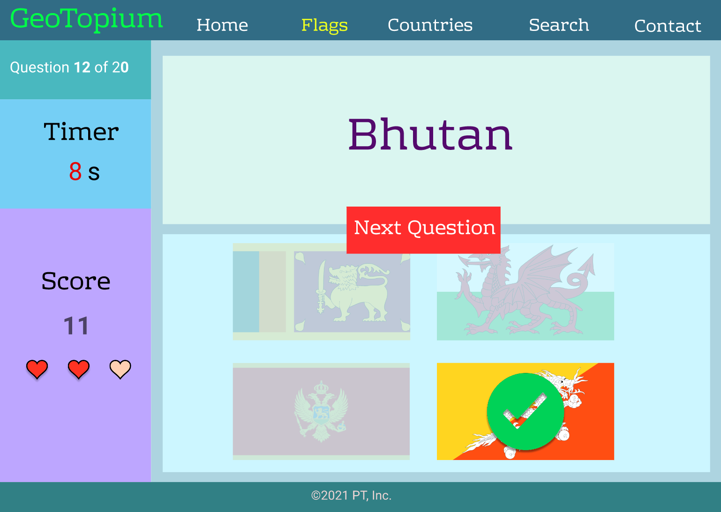

Figure 4: Flags Challenge - Question Page showing results of answer [Desktop View]

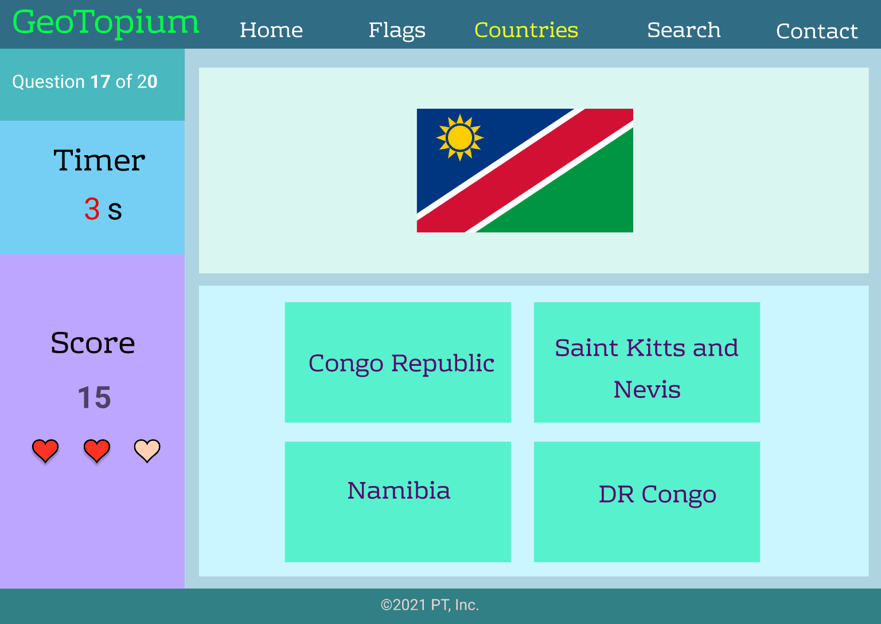

Figure 5: Countries Challenge - Question Page [Desktop View]

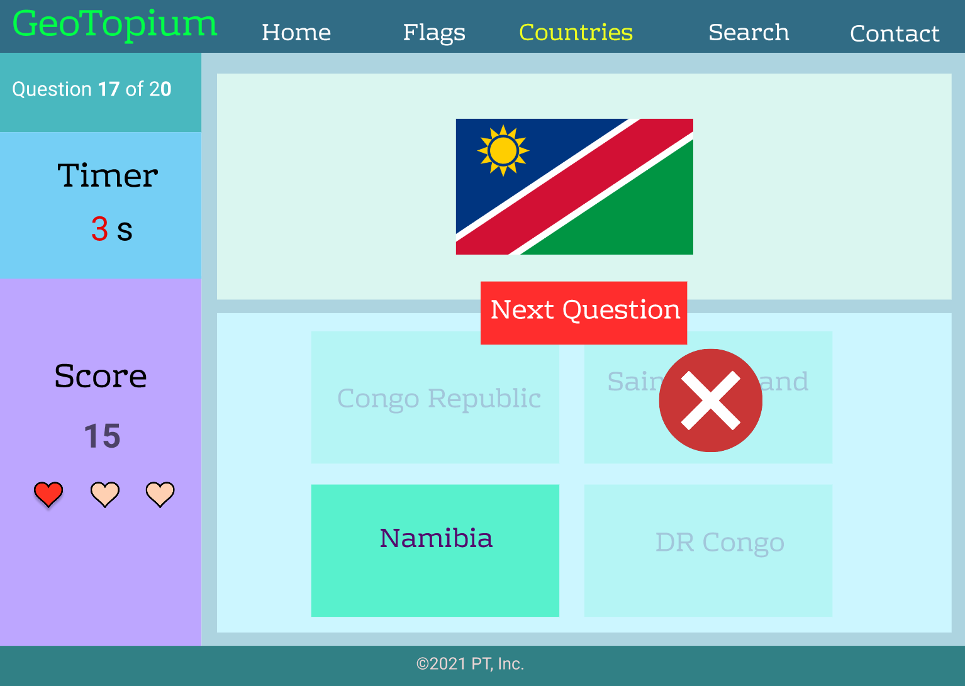

Figure 6: Countries Challenge - Question Page showing results of answer [Desktop View]



Figure 7: Search Box - after Search button is selected [Desktop View]

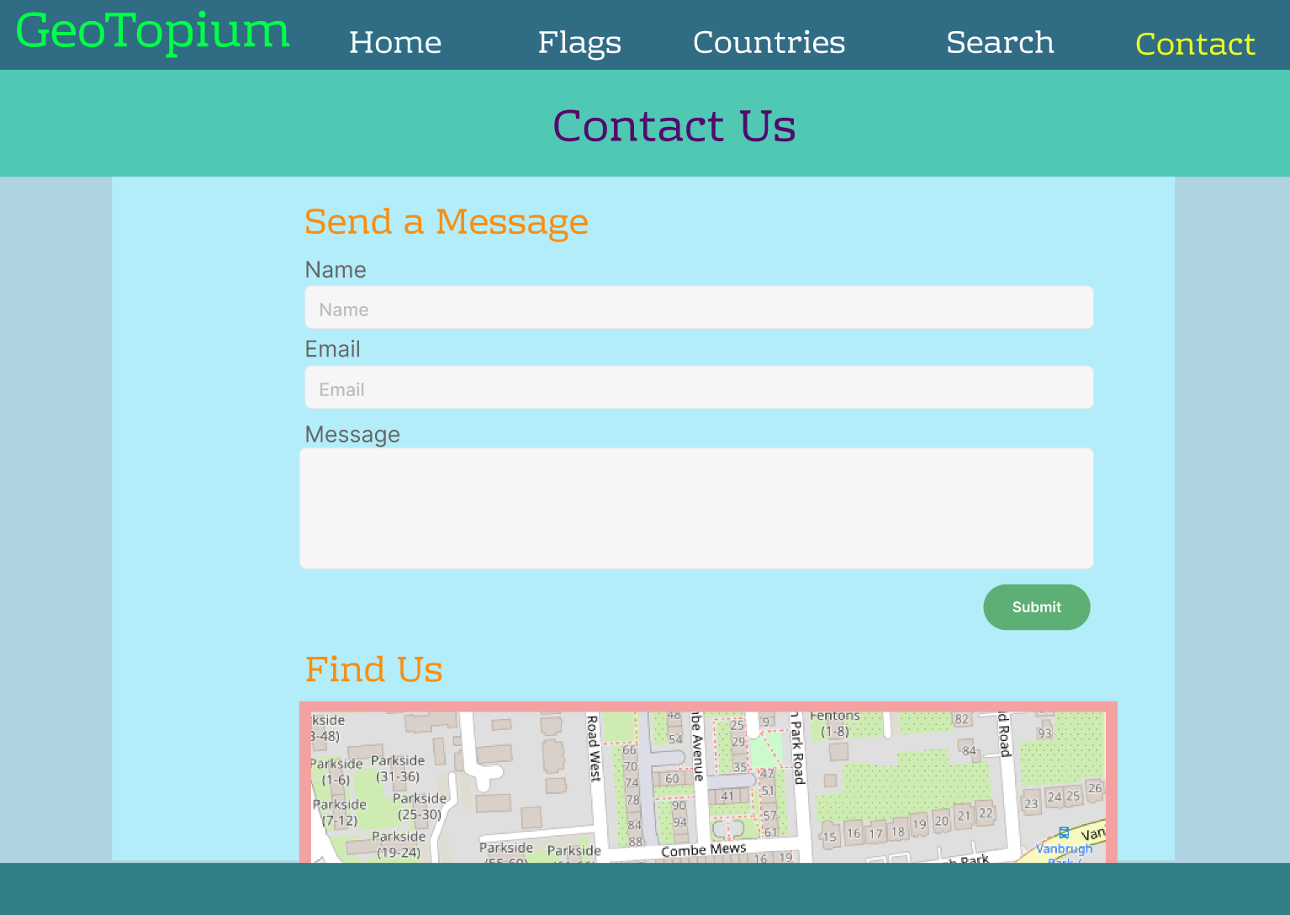

Figure 8: Contact Page [Desktop View]

### Mobile UX/UI

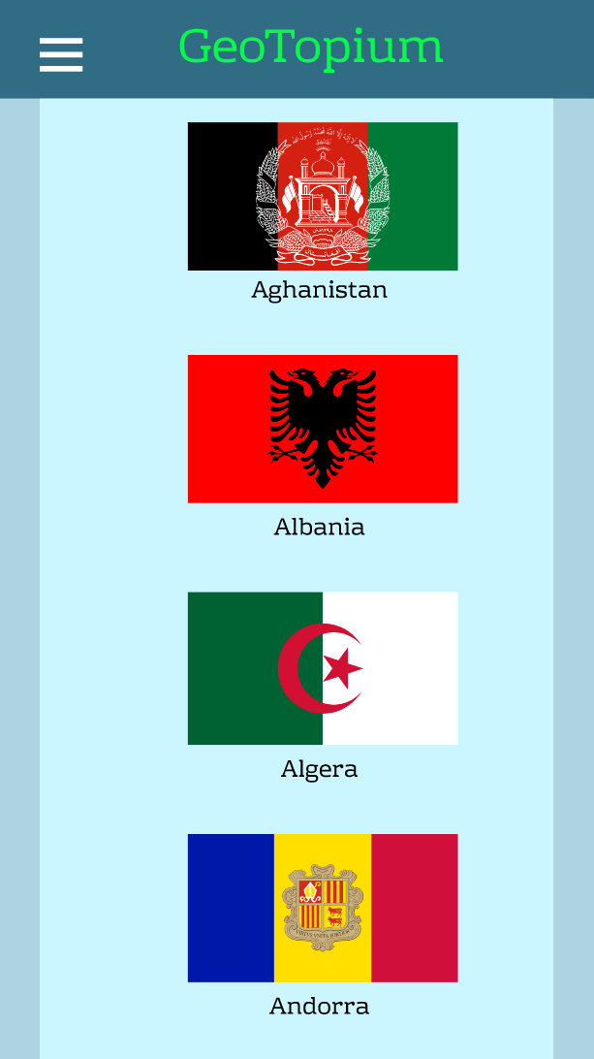 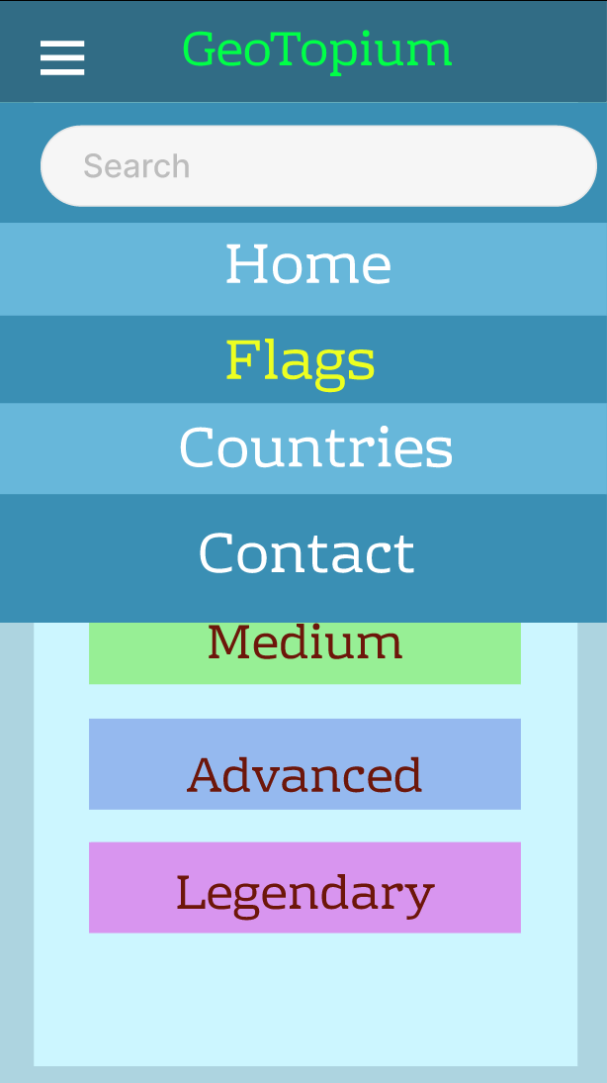

Figure 9: Home Page (Repository) [Mobile View] Figure 10: Navigation Bar (expanded) [Mobile View]

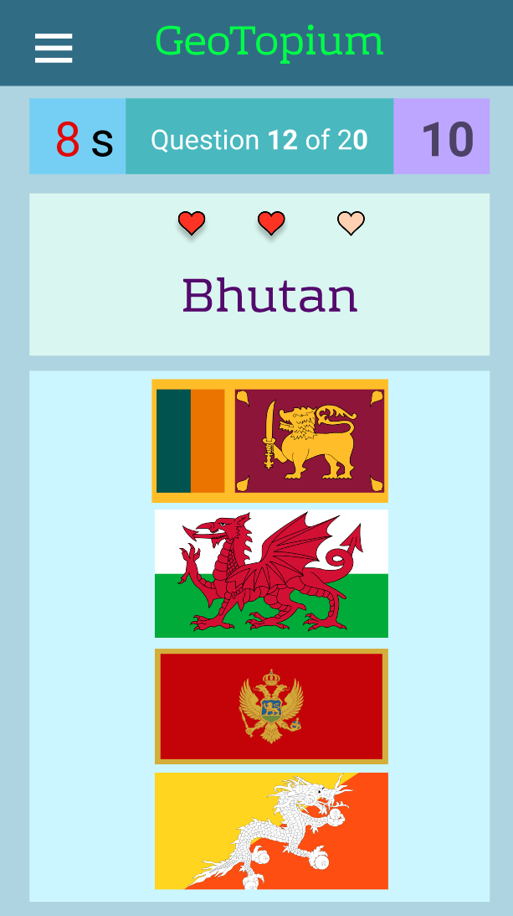 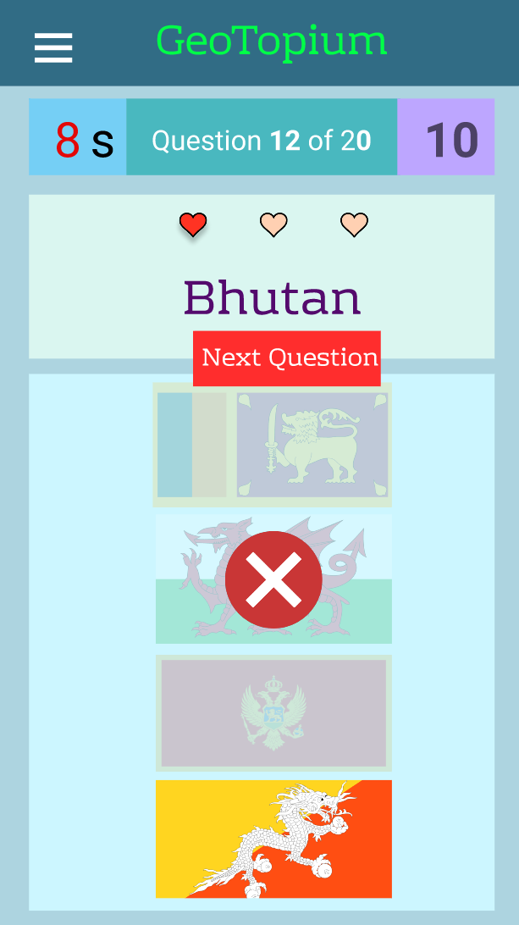

Figure 11: Flags Challenge - Question Page [Mobile View] Figure 12: Flags Challenge - Question Page showing results of answer [Mobile View]

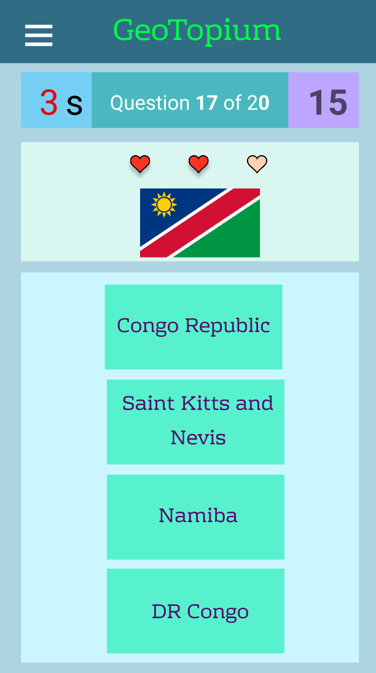 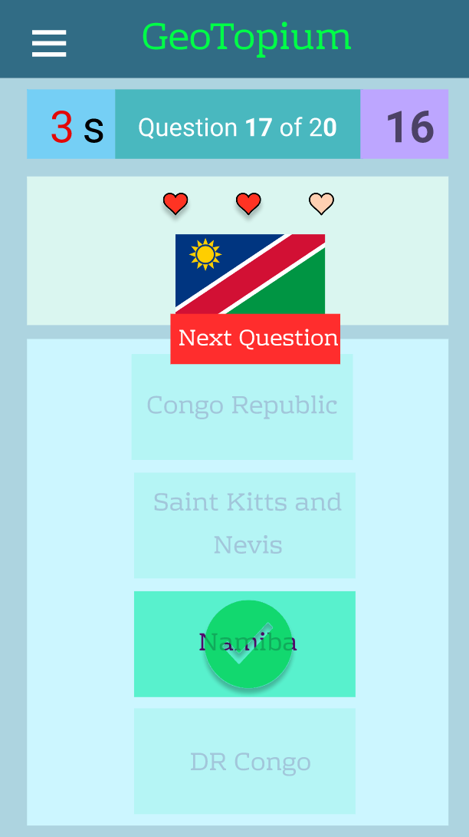

Figure 13: Countries Challenge - Question Page [Mobile View] Figure 14: Countries Challenge - Question Page showing results of answer [Mobile View]

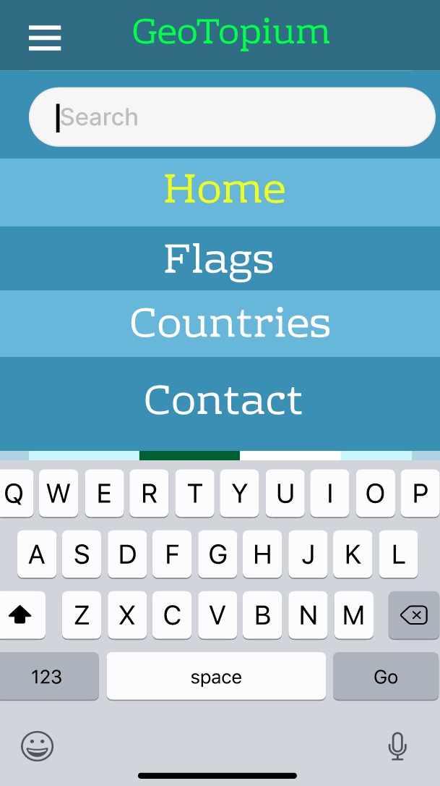 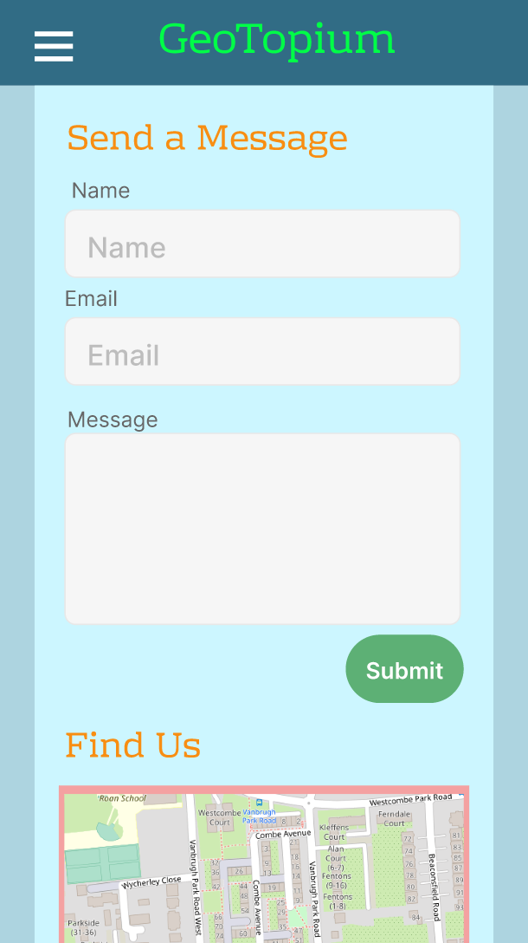

Figure 15: Search Box - after Search button is selected [Mobile View] Figure 16: Contact Page [Mobile View]